
Cloudli Connect Training
How to Set up a SCID Number
Lynn Daviault | 11/5/25 | Cloudli Connect Training

How to Set up a SCID Number
This guide provides a straightforward, step-by-step process for setting up a SCID number.

- Click “Telephony”
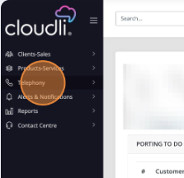

- Click “Numbers”
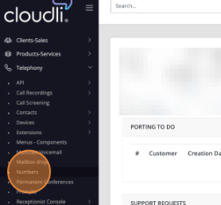

- Click “NEW”

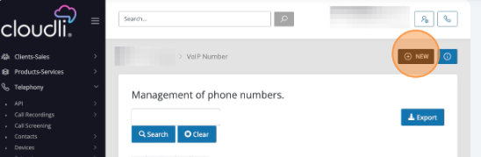
- Select the number desired to be an SCID Number
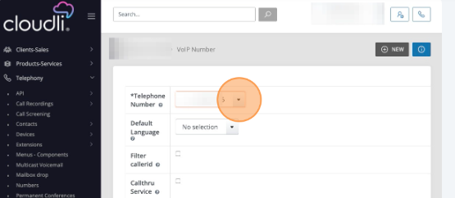

- Select the “English” option
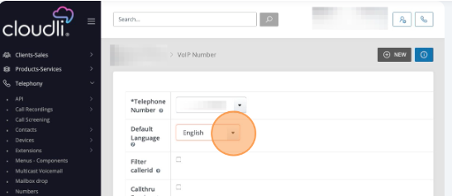

- Select the appropriate 911 address from the drop down menu
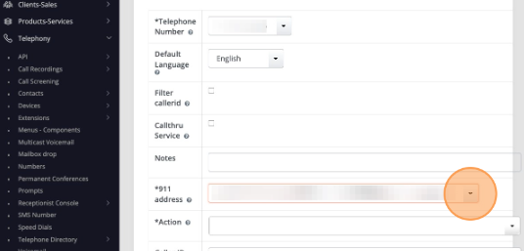

- Click on “Action” Menu
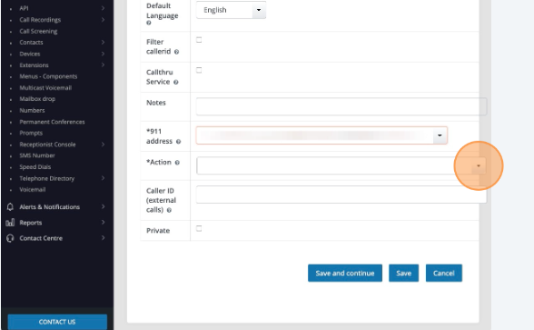

- Click “Route to previously connect extension” in the drop down menu
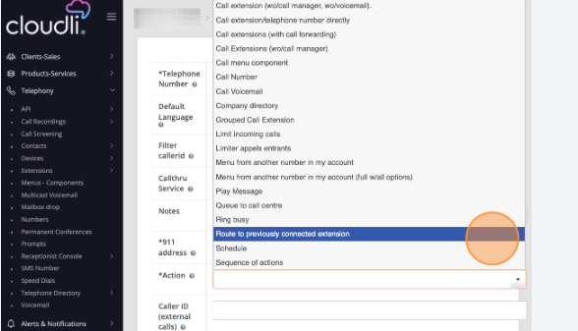

- Update the duration that supports your SCID use case
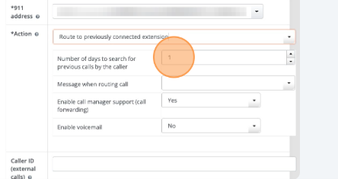
- Update the “Enable voicemail” drop down menu to “Yes”
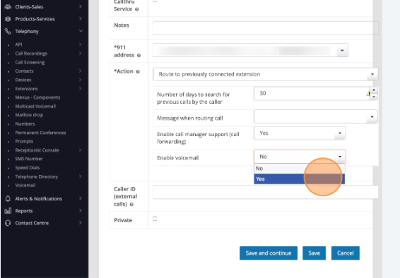

- Click “Save”
